Y1, 2 Maths KSP
Autumn Term
Place Value Numbers to 50 Autumn 1/ 2 weeks/10 lessons  Block will be repeated with numbers to 100 |  | Resources
Objectives | Ready to progress | White Rose | Power Maths
I can count in steps of 2, 3, and 5 from 0, and in tens from any number, forward or backward.  I can count on and back in 2s, 5s and 10s from any given number to 100. PV1  I can read and write numbers to at least 100 in numerals and in words. I can write all numbers in numerals and words to 20. PV1  I can say the number that is one more or one less than a number to 100. PV1  I can use place value and number facts to solve problems. all  I can count to and across 100, forwards and backwards beginning with 0 or 1 or from any given number. PV2  I can recognise the place value of each digit in a two-digit number (tens, ones). PV2  I can identify, represent and estimate numbers using different representations, including the number line. I can identify and represent numbers using objects and pictorial representations including the number line and use the language of equal to, more than, less (fewer), most, least. PV2  I can compare and order numbers from 0 up to 100; use <, > and = signs. PV3 & 4 | 1NPV–1 Count within 100, forwards and backwards, starting with any number.  1NPV–2 Reason about the location of numbers to 20 within the linear number system, including comparing using < > and =  2NPV–1 Recognise the place value of each digit in two-digit numbers, and compose and decompose two-digit numbers using standard and non-standard partitioning.  2NPV–2 Reason about the location of any two-digit number in the linear number system, including identifying the previous and next multiple of 10. | Unit 1: Count, read and write forwards and backwards- numbers to 50 only  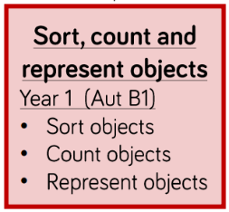  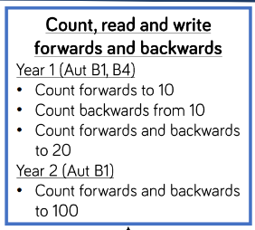  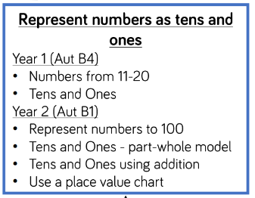  Unit 2: Representing numbers as tens and ones  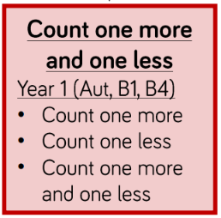  Unit 3: Comparing groups and numbers & Unit 4 Order numbers  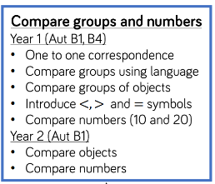  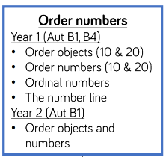 | Use the lessons across these units to pick out and teach numbers to 50 only  Year 1:  Unit 1 numbers to 10  Unit 2: Part-whole within 10  Unit 6: Numbers to 20  Unit 9: Numbers to 50

Addition and subtraction Numbers to 50 Autumn 1/ 2 weeks 10 lessons  Money objectives to be taught in next block after money. |  | Resources
Objectives | Ready to progress | White Rose | Power Maths
I can read, write and interpret the mathematical statements involving (+) and (=) signs.  I can show that addition of two numbers can be done in any order commutative).  I can recall and use addition facts to 20 fluently and derive and use related facts up to 100. I can recall and use all pairs of number bonds and related addition facts within 20.  I can add numbers using concrete objects, pictorial representations, and mentally, including: a 2-digit no and 1s or 10s; two 2-digit numbers; adding three 1-digit numbers. I can add 1-digit and 2-digit numbers to 20, including zero.  I can solve problems with addition: using concrete objects and pictorial representations; applying their increasing knowledge of mental and written methods. I can solve a one-step problem involving an addition, using concrete objects, pictorial representations.  I can recall and use subtraction facts to 20 fluently and derive and use related facts up to 100. I can recall and use all pairs of number bonds and related subtraction facts within 20.  I can subtract numbers using concrete objects, pictorial representations, and mentally, including: a 2-digit no and 1s or 10s; two 2-digit numbers. I can subtract 1-digit from 2-digit numbers to 20, including zero.  I can recognise and use the inverse relationship between addition and subtraction and use this to check calculations and missing number problems.  I can solve problems with subtraction: using concrete objects and pictorial representations; applying their increasing knowledge of mental and written methods. I can solve a one-step problem involving a subtraction, using concrete objects, pictorial representations. | 1AS–1 Compose numbers to 10 from 2 parts, and partition numbers to 10 into parts, including recognising odd and even numbers.  1AS–2 Read, write and interpret equations containing addition ( ), subtraction ( ) and equals ( ) symbols, and relate additive expressions and equations to real-life contexts.  1NF–1 Develop fluency in addition and subtraction facts within 10.  2NF–1 Secure fluency in addition and subtraction facts within 10, through continued practice.  2AS–1 Add and subtract across 10, for example:  2AS–2 Recognise the subtraction structure of ‘difference’ and answer questions of the form, “How many more…?”.  2AS–3 Add and subtract within 100 by applying related one-digit addition and subtraction facts: add and subtract only ones or only tens to/from a two-digit number.  2AS–4 Add and subtract within 100 by applying related one-digit addition and subtraction facts: add and subtract any 2 two-digit numbers. | Unit 2: Fact Families & Number Bonds  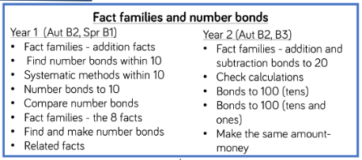  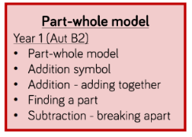  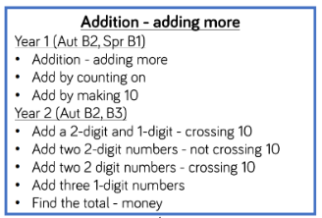  Unit 3: Addition – Adding More  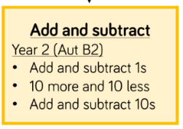  Unit 4: Subtraction and difference  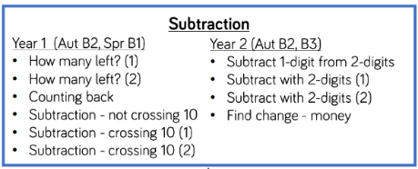  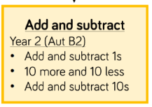  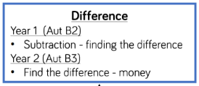  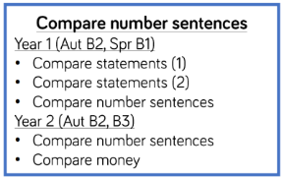  Unit 5: Compare Number sentences | Use the lessons across these units to pick out and teach numbers to 50 only  Year 1  Unit 3: Addition and subtraction within 10 (1)  Unit 4: Addition and subtraction within 10 (2)  Unit 7: Addition within 20  Unit 8: Subtraction within 20

Money: Autumn 1/ 1week/ 5 lessons |  | Resources
Objectives | Ready to progress | White Rose | Power Maths
I can recognise and use symbols for pounds (£) and pence (p); combine amounts to make a particular value. I can recognise and know the value of, all coins: £1; 50p; 20p; 10p; 5p; 2p and 1p and notes.  I can find different combinations of coins that equal the same amounts of money.  I can solve simple problems in a practical context involving addition and subtraction of money of the same unit, including giving change. | N/A | 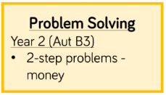  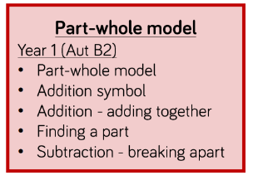  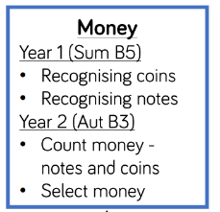  Unit1: Money | Year 1  Unit 18: Money  Year 2  Unit 4: Money

Time: Autumn 1/ 1 week/5 lessons |  | Resources
Objectives | Ready to progress | White Rose | Power Maths
I can sequence events in chronological order using language, such as before an after, next, first, today, yesterday and tomorrow, morning, afternoon and evening.  I can name the days of the week, months of the year, weeks, months and years.  I can tell the time to ‘o’clock’ and half past the hour and draw hands on a clock face to show these times.  I can tell and write the time including quarter past/to the hour and draw the hands on a clock face to show these times. |  | Unit 1: Telling the time  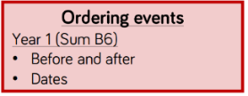  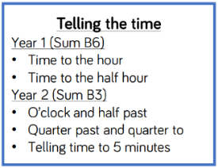 | Year 1  Unit 17: Time  Year 2  Unit 13- lessons 1/2/3  May need to supplement 5 minutes

Place Value Numbers to 100 Autumn 2/ 2 weeks /10 lessons  Teach anything not taught in block 1 and then repeat for numbers to 100 |  | Resources
Objectives | Ready to progress | White Rose | Power Maths
I can count in steps of 2, 3, and 5 from 0, and in tens from any number, forward or backward.  I can count on and back in 2s, 5s and 10s from any given number to 100. PV1  I can read and write numbers to at least 100 in numerals and in words. I can write all numbers in numerals and words to 20. PV1  I can say the number that is one more or one less than a number to 100. PV1  I can use place value and number facts to solve problems. all  I can count to and across 100, forwards and backwards beginning with 0 or 1 or from any given number. PV2  I can recognise the place value of each digit in a two-digit number (tens, ones). PV2  I can identify, represent and estimate numbers using different representations, including the number line. I can identify and represent numbers using objects and pictorial representations including the number line and use the language of equal to, more than, less (fewer), most, least. PV2  I can compare and order numbers from 0 up to 100; use <, > and = signs. PV3 & 4 | 1NPV–1 Count within 100, forwards and backwards, starting with any number.  1NPV–2 Reason about the location of numbers to 20 within the linear number system, including comparing using < > and =  2NPV–1 Recognise the place value of each digit in two-digit numbers, and compose and decompose two-digit numbers using standard and non-standard partitioning.  2NPV–2 Reason about the location of any two-digit number in the linear number system, including identifying the previous and next multiple of 10. | Unit 1: Count, read and write forwards and backwards- numbers to 100 only  Unit 2: Representing numbers as tens and ones  Unit 3: Comparing groups and numbers & Unit 4 Order numbers | Year 1  Unit 16: Numbers to 100  Year 2:  Unit 1 Numbers to 100

Addition and subtraction Numbers to 100 Autumn 2 / 2 weeks 10 lessons  Money objectives to now be included, include anything not covered and numbers to 100 |  | Resources
Objectives | Ready to progress | White Rose | Power Maths
I can read, write and interpret the mathematical statements involving (+) and (=) signs.  I can show that addition of two numbers can be done in any order commutative).  I can recall and use addition facts to 20 fluently and derive and use related facts up to 100. I can recall and use all pairs of number bonds and related addition facts within 20.  I can add numbers using concrete objects, pictorial representations, and mentally, including: a 2-digit no and 1s or 10s; two 2-digit numbers; adding three 1-digit numbers. I can add 1-digit and 2-digit numbers to 20, including zero.  I can solve problems with addition: using concrete objects and pictorial representations; applying their increasing knowledge of mental and written methods. I can solve a one-step problem involving an addition, using concrete objects, pictorial representations.  I can recall and use subtraction facts to 20 fluently and derive and use related facts up to 100. I can recall and use all pairs of number bonds and related subtraction facts within 20.  I can subtract numbers using concrete objects, pictorial representations, and mentally, including: a 2-digit no and 1s or 10s; two 2-digit numbers. I can subtract 1-digit from 2-digit numbers to 20, including zero.  I can recognise and use the inverse relationship between addition and subtraction and use this to check calculations and missing number problems.  I can solve problems with subtraction: using concrete objects and pictorial representations; applying their increasing knowledge of mental and written methods. I can solve a one-step problem involving a subtraction, using concrete objects, pictorial representations. | 1AS–1 Compose numbers to 10 from 2 parts, and partition numbers to 10 into parts, including recognising odd and even numbers.  1AS–2 Read, write and interpret equations containing addition ( ), subtraction ( ) and equals ( ) symbols, and relate additive expressions and equations to real-life contexts.  1NF–1 Develop fluency in addition and subtraction facts within 10.  2NF–1 Secure fluency in addition and subtraction facts within 10, through continued practice.  2AS–1 Add and subtract across 10, for example:  2AS–2 Recognise the subtraction structure of ‘difference’ and answer questions of the form, “How many more…?”.  2AS–3 Add and subtract within 100 by applying related one-digit addition and subtraction facts: add and subtract only ones or only tens to/from a two-digit number.  2AS–4 Add and subtract within 100 by applying related one-digit addition and subtraction facts: add and subtract any 2 two-digit numbers. | Unit 2: Fact Families & Number Bonds  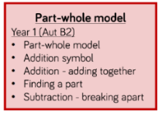  Unit 3: Addition – Adding More  Unit 4: Subtraction and difference  Unit 5: Compare Number sentences | Year 2  Unit 2: Addition and subtraction (1)  Unit 3: Addition and subtraction (2)

Multiplication Autumn 2 / 2 weeks 10 lessons |  | Resources
Objectives | Ready to progress | White Rose | Power Maths
I can recall and use multiplication facts for the 2, 5 and 10 multiplication tables, including recognising odd and even numbers.  I can calculate mathematical statements for multiplication within the multiplication tables and write them using the multiplication (×) and equals (=) signs.  I can show that multiplication of two numbers can be done in any order (commutative).  I can solve problems involving multiplication, using materials, arrays, repeated addition, mental methods, and multiplication facts, including problems in contexts.  I can solve a one-step problem involving a multiplication, using concrete objects, pictorial representations and arrays with the support of the teacher. | 2MD–1 Recognise repeated addition contexts, representing them with multiplication equations and calculating the product, within the 2, 5 and 10 multiplication tables  2MD–2 Relate grouping problems where the number of groups is unknown to multiplication equations with a missing factor, and to division equations (quotitive division). | Unit 1: Counting in Multiples  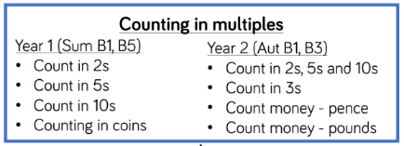  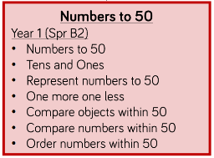  Unit 2: Equal Groups  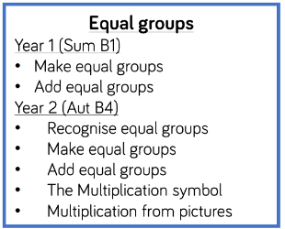  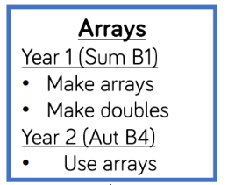  Unit 3: Arrays  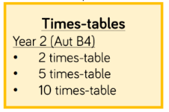 | Year 1  Unit 12: Multiplication  Year 2  Unit 5: Multiplication and division (1)

Statistics Autumn 2 / 5 lessons |  | Resources
Objectives | Ready to progress | White Rose | Power Maths
I can interpret and construct simple pictograms, tally charts, block diagrams and simple tables.  I can ask and answer simple questions by counting the number of objects in each category and sorting the categories by  quantity;  I can ask and answer questions about totalling and comparing categorical data. | N/A | 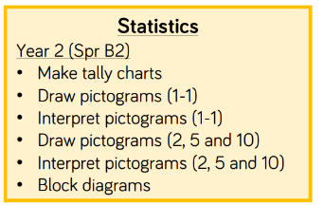  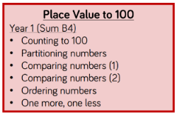 | Year 2  Unit 7: Statistics

Length and Height: Autumn 1 / 1 weeks / 5 lessons |  | Resources
Objectives | Ready to progress | White Rose | Power Maths
I can choose/use appropriate standard units to estimate/measure length/height (m/cm); to nearest unit, using rulers.  I can compare, describe and solve practical problems for lengths and heights (long/short, etc..).  I can measure and begin to record the following – lengths and heights.  I can compare and order lengths and record the results using >, < and | N/A | 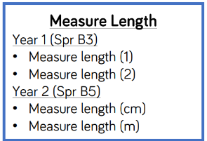  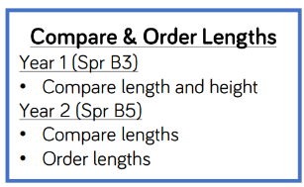  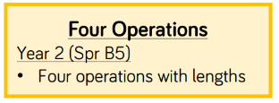 | Year 1 –  Unit 10: Introducing length and height  Year 2 –  Unit: Length and height

