1. Year Groups
Years 5/6
3. Key learning in design and technology
Prior learning
• Have knowledge and understanding about food hygiene, nutrition, healthy eating and a varied diet.
• Be able to use appropriate equipment and utensils, and apply a range of techniques for measuring out, preparing and combining ingredients.

Designing
• Generate innovative ideas through research and discussion with peers and adults to develop a design brief and criteria for a design specification.
• Explore a range of initial ideas, and make design decisions to develop a final product linked to user and purpose.
• Use words, annotated sketches and information and communication technology as appropriate to develop and communicate ideas.

Making
• Write a step-by-step recipe, including a list of ingredients, equipment and utensils
• Select and use appropriate utensils and equipment accurately to measure and combine appropriate ingredients.
• Make, decorate and present the food product appropriately for the intended user and purpose.

Evaluating
• Carry out sensory evaluations of a range of relevant products and ingredients. Record the evaluations using e.g. tables/graphs/charts such as star diagrams.
• Evaluate the final product with reference back to the design brief and design specification, taking into account the views of others when identifying improvements.
• Understand how key chefs have influenced eating habits to promote varied and healthy diets.

Technical knowledge and understanding
• Know how to use utensils and equipment including heat sources to prepare and cook food.
• Understand about seasonality in relation to food products and the source of different food products.
• Know and use relevant technical and sensory vocabulary.
2. Aspect of D&T
Food

Focus
Celebrating culture and seasonality
10. Investigative and Evaluative Activities (IEAs)
• Children use first hand and secondary sources to carry out relevant research into existing products to include personal/cultural preferences, ensuring a healthy diet, meeting dietary needs and the availability of locally sourced/seasonal/organic ingredients. This could include a visit to a local bakery, farm, farm shop or supermarket e.g. What ingredients are sourced locally/in the UK/from overseas? What are the key ingredients needed to make a particular product? How have ingredients been processed? What is the nutritional value of a product?
• Children carry out sensory evaluations of a variety of existing food products and ingredients relating to the project. The ingredients could include those that could be added to a basic recipe such as herbs, spices, vegetables or cheese. These could be locally sourced, seasonal, Fair Trade or organic. Present results in e.g. tables/graphs/charts and by using evaluative writing.
• Use a range of questions to support children’s ability to evaluate food ingredients and products e.g. What ingredients help to make the product spicy/crisp/crunchy etc? What is the impact of added ingredients/finishes/shapes on the finished product?
• Research key chefs and how they have promoted seasonality, local produce and healthy eating.
12. Focused Tasks (FTs)
• Demonstrate how to measure out, cut, shape and combine e.g. knead, beat, rub and mix ingredients.
• Demonstrate how to use appropriate utensils and equipment that the children may use safely and hygienically.
• Techniques could be practised following a basic recipe to prepare and cook a savoury food product.
• Ask questions about which ingredients could be changed or added in a basic recipe such as types of flour, seeds, garlic, vegetables. Consider texture, taste, appearance and smell.
• When using a basic dough recipe, explore making different shapes to change the appearance of the food product e.g. Which shape is most appealing and why?
14. Design, Make and Evaluate Assignment (DMEA)
• Develop a design brief and simple design specification with the children within a context that is authentic and meaningful. This can include design criteria relating to nutrition and healthy eating.
• Discuss the purpose of the products that the children will be designing, making and evaluating and who the products will be for.
• Ask children to generate a range of ideas encouraging innovative responses. Agree on design criteria that can be used to guide the development and evaluation of the children’s product.
• Using annotated sketches, discussion and information and communication technology if appropriate, ask children to develop and communicate their ideas.
• Ask children to record the steps, equipment, utensils and ingredients for making the food product drawing on the knowledge, understanding and skills learnt through IEAs and FTs.
• Evaluate the work as it progresses and the final product against the intended purpose and user reflecting on the design specification previously agreed.
7. Links to topics and themes
Festivals Cultures/Celebrating Diversity Celebrations Special Events Seasons Sustainability Food Our Local Community other – specify
4. What could children design, make and evaluate?
bread pizza savoury biscuits savoury scones savoury muffin cereal snack soup other – specify
8. Possible contexts
home school leisure culture traditions enterprise healthy eating local environment/community sustainability wider environment global citizenship other – specify
5. Intended users
themselves younger children parents older people grandparents visitors people with special dietary needs consumers from a variety of cultures other – specify

9. Project title
Design, make and evaluate a________ (product) for __________ (user) for _________ (purpose)
To be completed by the teacher. Use the project title to set the scene for children’s learning prior to activities in 10, 12 and 14.
6. Purpose of products
festival celebration special event for sale
food for travel picnic visit other – specify
11. Related learning in other subjects
• Mathematics and computing – making use of mathematical and computing skills to present results of sensory evaluations graphically, handling and interpreting data.
• Spoken language – developing relevant vocabulary including sensory descriptors. Give well-structured explanations.
• Science – using and developing skills of observing, questioning, changing state of ingredients.
• Geography – distribution of natural resources i.e. food.
• Computing – use technology purposefully to retrieve digital content.
13. Related learning in other subjects
• Science – properties of materials and changes of state.
• Mathematics – measuring mass kg/g. Understand and use approximate equivalences between metric and imperial units.
• Spoken language – new technical vocabulary.
15. Related learning in other subjects
• Mathematics – measurement of mass kg/g; understand and use approximate equivalence of metric and imperial units.
• Art and design – using and developing drawing skills.
• Spoken language – articulate and justify answers and opinions. Listen and respond to adults and peers.
• Writing – purpose of writing e.g. for planning and evaluation.
• Mathematics – measurement of mass kg/g.
• Science – recognise the impact of diet on the way their bodies function.
16. Possible resources
information about food from around the world
video clips of foods in the context of where they come from, used and eaten
range of relevant examples of foods to taste and evaluate
basic recipes
suitable equipment and utensils to make and cook recipes such as: weighing scales, measuring jugs, bowls, spoons – various sizes, baking trays, parchment paper, plastic film
17. Key vocabulary
ingredients, yeast, dough, bran, flour, wholemeal, unleavened, baking soda, spice, herbs

fat, sugar, carbohydrate, protein, vitamins, nutrients, nutrition, healthy, varied, gluten, dairy, allergy, intolerance, savoury, source, seasonality

utensils, combine, fold, knead, stir, pour, mix, rubbing in, whisk, beat, roll out, shape, sprinkle, crumble

design specification, innovative, research, evaluate, design brief
18. Key competencies
problem-solving teamwork negotiation consumer awareness organisation motivation persuasion leadership perseverance
other – specify
20. Overall potential of project
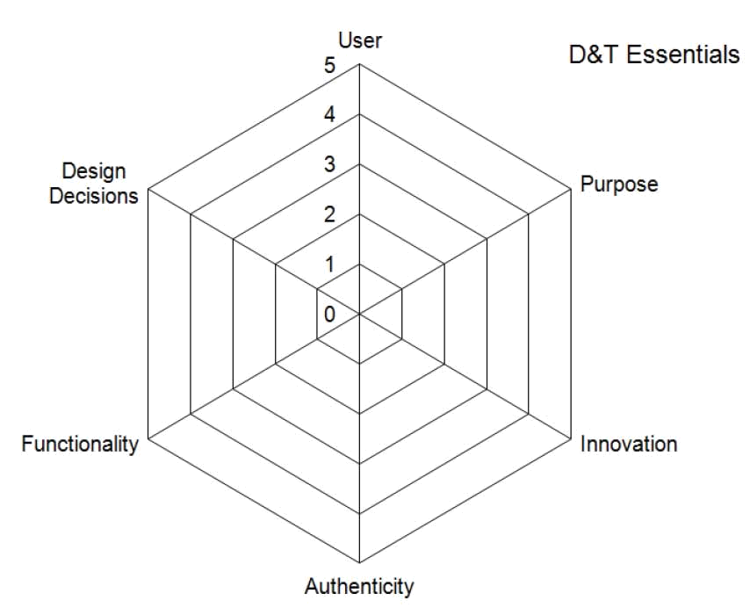

19. Health and safety
Pupils should be taught to work safely and hygienically, using tools, equipment, techniques and ingredients appropriate to the task. Prior to undertaking this project risk assessments should be carried out, including identifying whether there are children who are not permitted to taste or handle any food ingredients or products.

