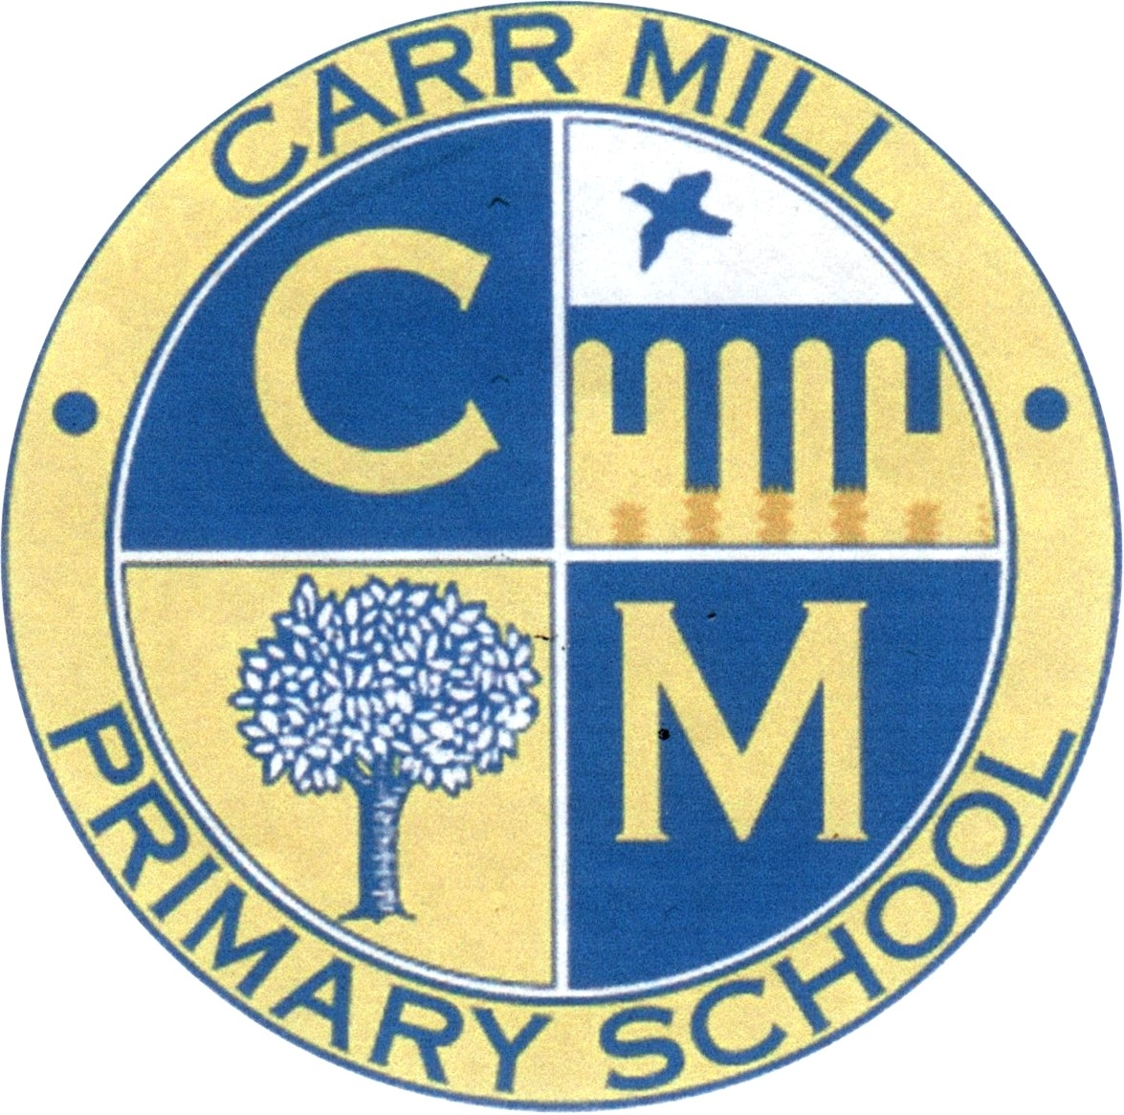
Carr Mill Primary School

School Holidays for 2024/25
Term | Opens on | Closes on
Autumn Term 2024 | Tuesday 3rd September 2024 | Friday 25th October 2024
Autumn Term 2024 | Tuesday 5th November 2024 | Friday 20th  December 2024
Spring Term  2025 | Monday 6th January 2025 | Friday 14th February 2025
Spring Term  2025 | Monday 24th February 2025 | Friday 4th April  2025
Summer Term  2025 | Tuesday 22nd April 2025 | Friday 23rd  May 2025
Summer Term  2025 | Tuesday 3rd June 2025 | Friday 18th July  2025
School also closed: | Easter Monday  Monday 21st April 2025  Bank Holiday  Monday 5th  May 2025 | INSET days  Monday 2nd September 2024  Monday 4th November 2024  Monday 2nd June 2025  Monday 21st July 2025  Tuesday 22nd July 2025  INSET days are in staff educational training days-children are not in school on these days

