The Primary PE and sport premium

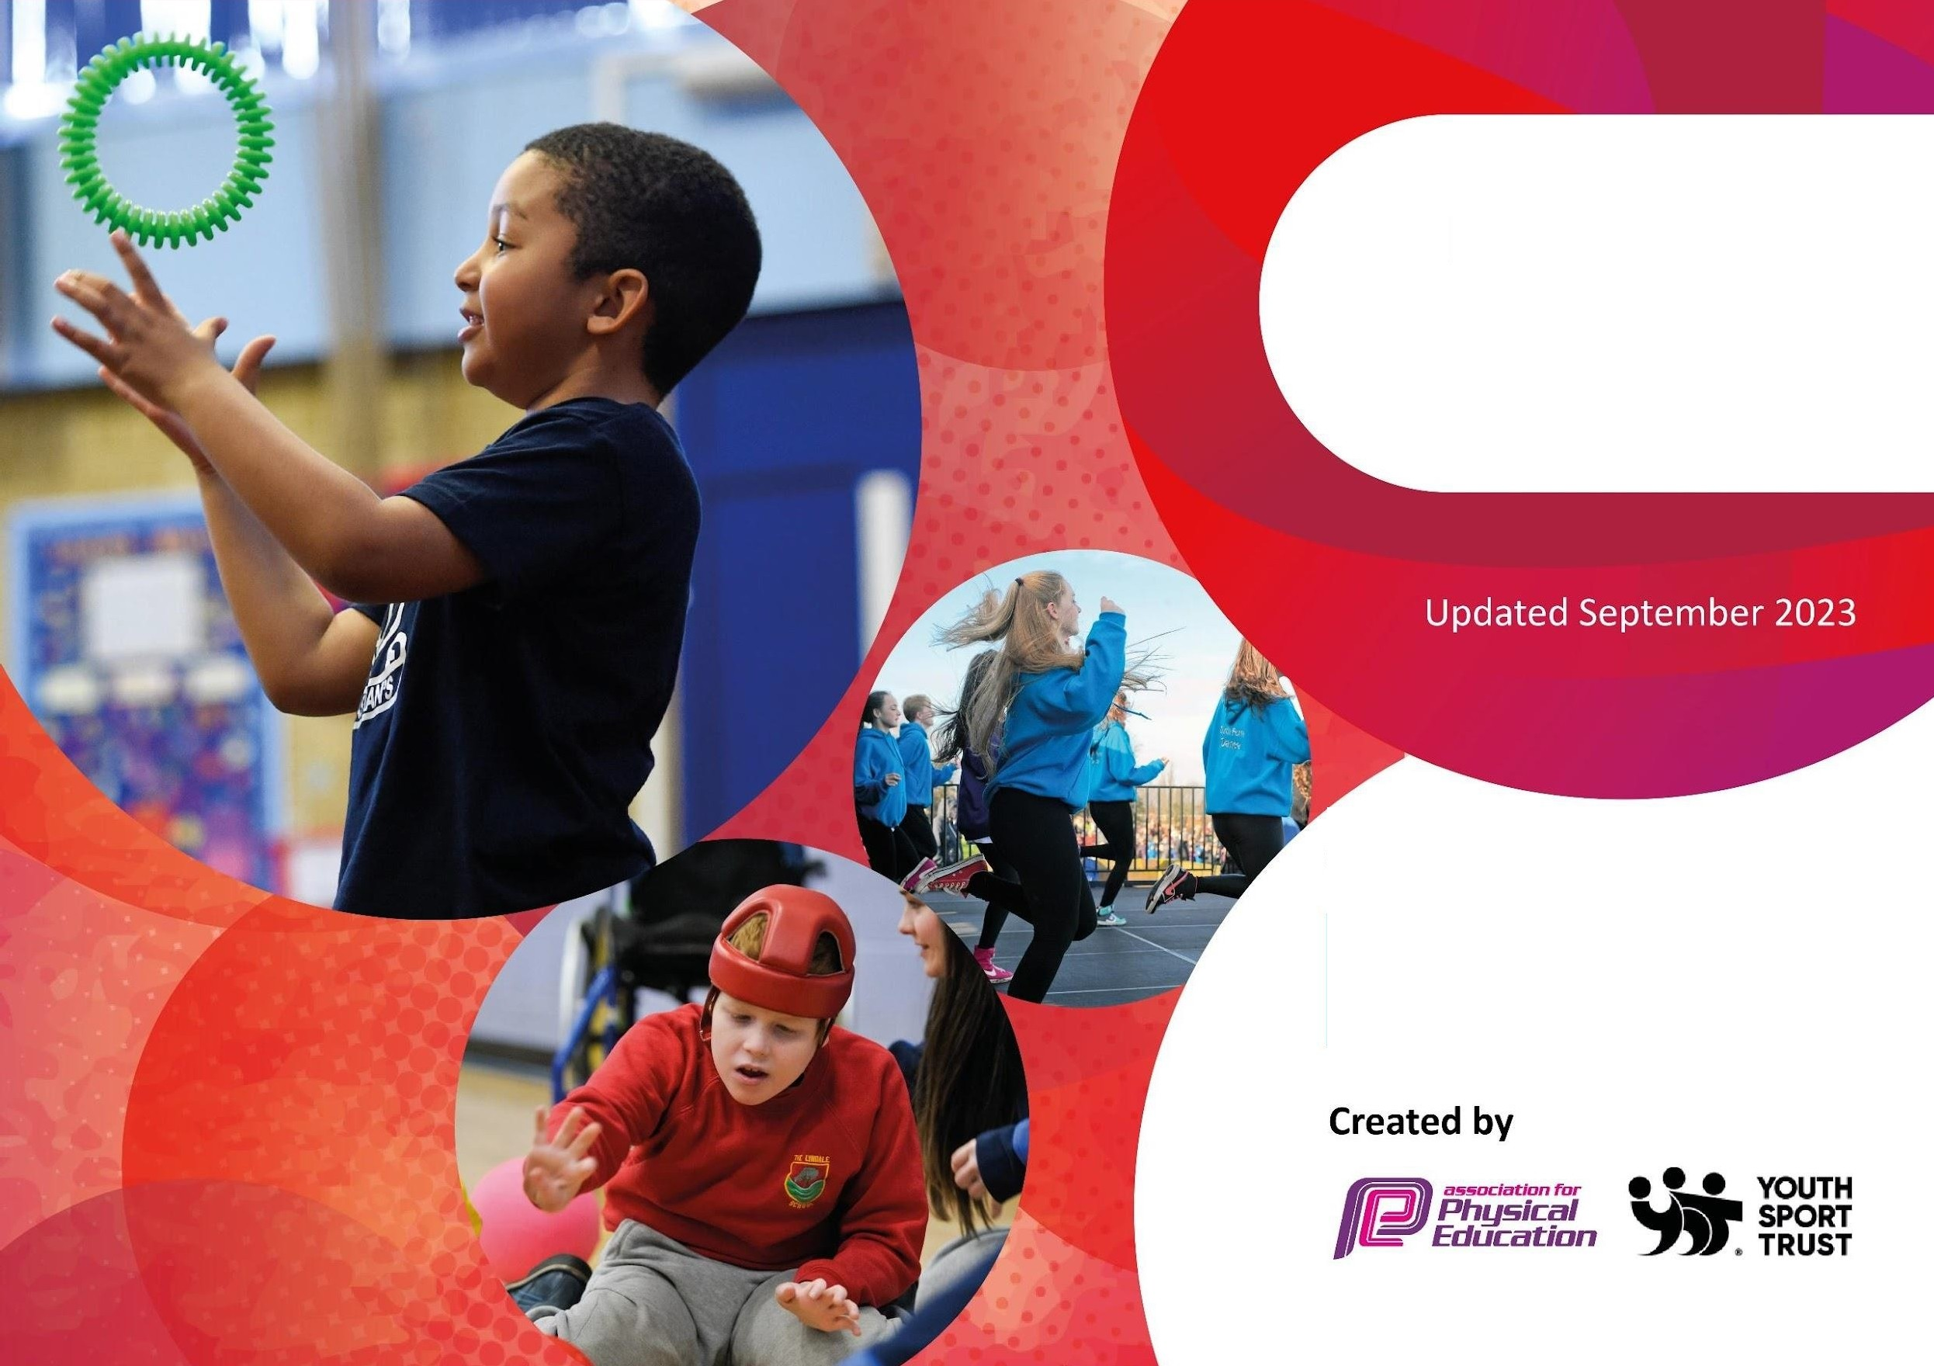

Planning, reporting and evaIuating website too I

**Commissioned by**

•

Department for Education

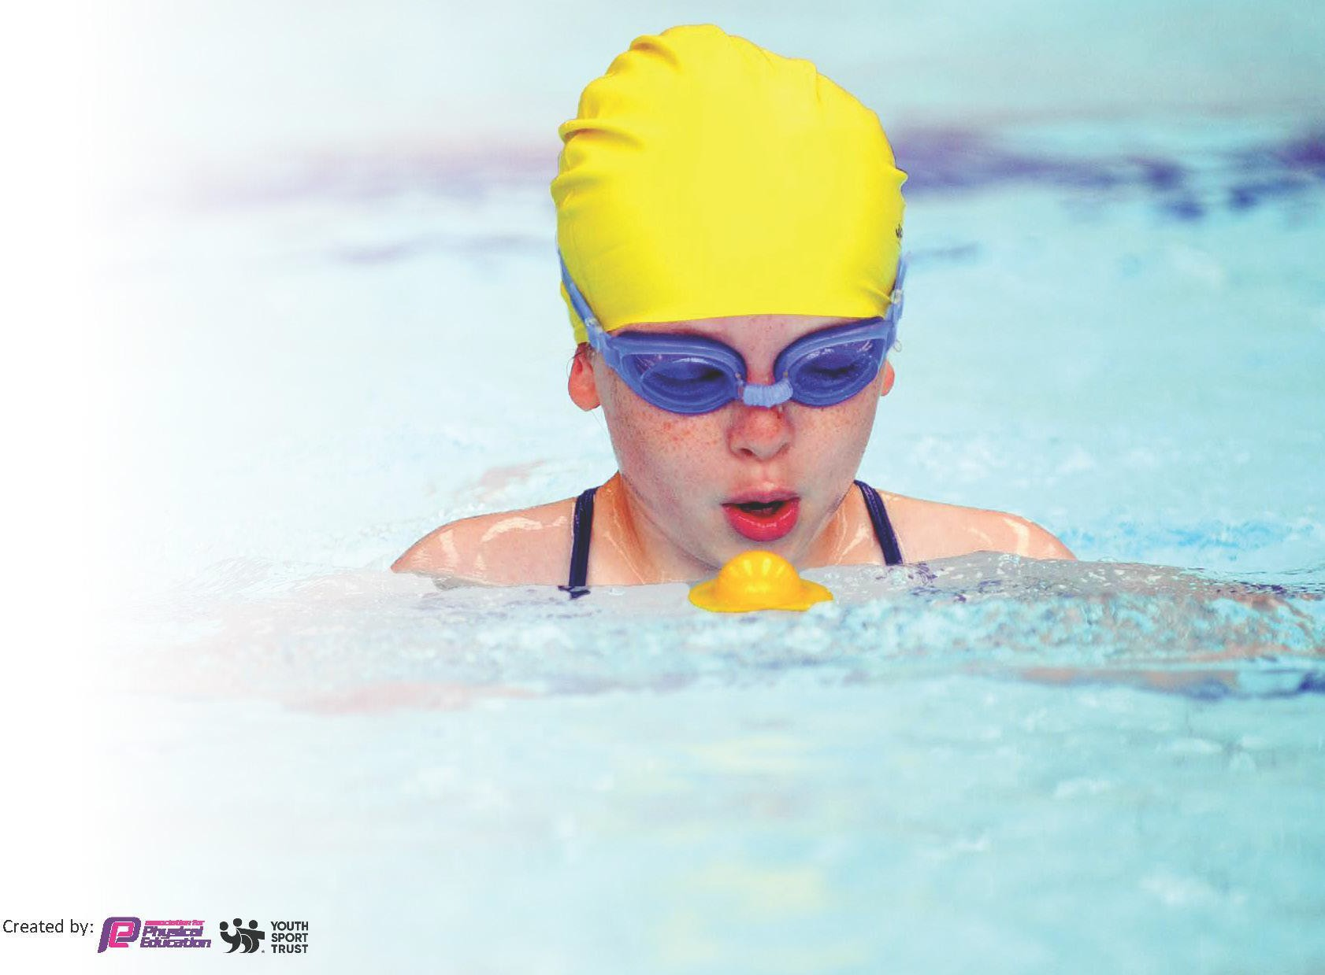This template can be used for multiple purposes:

* It enables schools to effectively plan their use of the Primary PE and sport premium
* It helps schools to meet the requirements (as set out in guidance) to publish information on their Primary PE and sport premium
* It will be an effective document to support Ofsted inspections enabling schools to evidence progress in Physical Education (PE) and evidence swimming attainment, which forms part of the PE National Curriculum. We would recommend schools consider

the Intent, Implementation and Impact of any spend, as examined within the Education Inspection Framework.

It is important that your grant is used effectively and based on school need.

Schools must use the funding to make **additional and sustainable**

**improvements** to the quality of the PE, School Sport and Physical Activity (PESSPA)

they offer. This means that you should use the Primary PE and sport premium to:

* Build capacity and capability within the school to ensure that improvements made now will benefit pupils joining the school in future years
* Develop or add to the PESSPA activities that your school already offers.

**The Primary PE and sport premium should not be used to fund capital spend projects; the school’s core budget should fund these. Further detail on capital expenditure can be found in the updated** [**Primary PE and sport premium guidance**](https://www.gov.uk/guidance/pe-and-sport-premium-for-primary-schools)**.**

by:

The Primary PE and sport premium guidance, outlines 5 key priorities that funding should be used towards. It is not

necessary that spending has to meet all the key priorities, you should select the priorities that you aim to use any funding towards.

Although completing this template is not a requirement for schools, schools are required to publish details of how they spend this funding. Schools must also outline what the impact this funding has had on pupils’ PE and sport participation and attainment and how any spending will be sustainable in the future. **All funding must be spent by 31st July 2024.**

The Department for Education has worked closely with the Association for Physical Education (afPE) and the Youth Sport Trust (YST) to develop this template and encourages schools to use it. This template is an effective way of meeting the reporting requirements of the Primary PE and sport premium.

**Review of last year’s spend and key achievements (2022/2023)**

We recommend you start by reflecting on the impact of current provision and reviewing your previous spend.

|  |  |  |
| --- | --- | --- |
| **Activity/Action** | **Impact** | **Comments** |
| Enhanced success in inter school local authority competitions and tournaments. Pupils from across the school will demonstrate greater levels of success in School Games competitions through the delivery of a bespoke and detailed PE curriculum using new planning strategies and resources.  • 2. Improved levels of participation in a wider range of extra-curricular sports activities across the school. Particular focus on KS1 and EYFS.  • 3. To ensure that delivery of PE sessions is of a consistently high standard and assessed accurately through the implementation of new PE planning resources through Edstart and CPD for staff.  4. Extra swimming sessions for UKS2 children | School has ensured greater participation in inter school tournaments; particularly for KS1. Pupils have engaged well and enjoyed representing the school. Consequently, pupils have developed a sense of pride and self esteem.  • 2. seasonal timetable of activities is planned to ensure coverage for all year groups. Participation levels are monitored to ensure all pupil groups are catered for.  • School has invested in resources to help support the delivery of quality PE sessions. Complete PE and PE packages have developed staff CPD and resulted in high quality delivery. | 1. Transport costing and availability issues have meant that we have been unable to attend as many competitions as we would have liked. This is planned to be addressed in the coming year with a different strategy. It is hoped to train staff in mini-bus driving and hire through a local company. Thus, reducing costs and reducing the risk of missing competitions through lack of available transport.   • 2. Pupil voice sessions have been used on a termly basis to highlight any specific club pupils would like. This helps to formulate an offer for the following year.  • 3. Complete PE and PE Planning are now fully integrated into the curriculum. These will be reviewed on an annual basis to ensure high standards.  4> Due to the closure of Parr baths UKS2 children missed out on swimming over 2 years. |

**Key priorities and Planning**

This planning template will allow schools to accurately plan their spending.

|  |  |  |  |
| --- | --- | --- | --- |
| **Key indicator to meet Key indicator 1:** The engagement of all pupils in regular physical activity – Chief Medical Officers guidelines recommend that primary school pupils undertake at least 30 minutes of physical activity a day in school | | | |
| **Action – what are you planning to do** | **Who does this action impact?** | **Impacts and how sustainability will be achieved?** | **Cost linked to the action** |
| To ensure all pupils have the opportunity to further improve their water confidence. To increase the number of pupils who can confidently swim swim by the end of KS2. | All KS2 pupils to receive additional over and above NC requirements swimming lessons throughout the year. An additional half term per year group- Y5/4 and 2 terms Y6 | Improving the quality of the swimming experiences for all of the children.  Greater percentage of children by the end of Yr6 are able to swim 25m, greater percentage of children by the end of Yr6 are able to swim a variety of strokes competently, greater percentage of children by the end of Yr6 able to self –rescue | Additional cost  £10,210 |
| To engage 100% of the children in a range of sporting and healthy lifestyle activities from Reception through to Year 6 | Whole school Healthy and Active Week | ***All children from Nurs-Y6 engaged in intra school competition.***  Pupils able to differentiate between healthy and unhealthy lifestyle choices. ***100% pupils engage in intra school competitions***  ***100% pupils are introduced to new physical activities***  ***100% pupils who do not normally engage in extra curricular clubs are participating in the Healthy and Active activities*** Mentoring support to young people experiencing wellbeing issues as well as creating innovative sport and physical activity opportunities for a targeted group of young people – increasing levels of activity in a safe and supported environment.  Families and pupils are offered the opportunity to learn about healthy lifestyle choices. Parents and pupils understand the importance of healthy lifestyle choice, feel supported in this and begin to adopt these ideas to their everyday lives. Making families physically literate. | £2000- equipment and resources inc supply to release teachers to deliver |
| Support and Mentoring for Gifted and Talented sports athletes to attain their potential under the training of acknowledged experts in their field | Pathways signposted to access additional support | Children are able to realise their potential. Gifted & talented children signposted to expertise outside school. **Children made aware of training and facilities available to them via email, newsletter.**  ***Coaches used to help identify G&T. Children and families given information regarding additional training.*** | £200 |
| Audit of resources by Sport Safe to ensure equipment up to the required standard | Resources are tested to see if meet health and safety regulations. Repairs made where necessary | Equipment annually checked to ensure safe. On calendar for academic Year 2023-2024 Sport equipment to meet health and safety standards. Equipment is safe for children  to use in all PE sessions ***Audit of sport resources carried out, additional resources purchased as and when required.*** | £500 |
| To increase the physical activity levels by maintaining the activities available to all pupils. See Extended Schools Club Provision. | All pupils. A wide variety of extra- curricular clubs to run each week throughout the year.  x 2 sports club per week  Morning club | Wide variety of sports covered.  PP data and non-PP data to be viewed termly.  Continue to monitor clubs on offer.  Review attendance data half termly. | £30 per club x 1 per week.  Autumn only = 15 weeks  15 x 30 =£450  Rest subsidized £ 10 per week x 23 weeks = £230  Total £680 |
| To increase physical activity levels links to be made to competitions calendar 2023-2024. | Participation in activities/competitions to be organized half termly 2023-24 to ensure all year groups have opportunities in a wide range of sports to represent the school in competition. | Calendar organised for 2023- 2024 to ensure all year groups participating in a range of sports. ***Calendar sent out by SGO (Daniel Bacon) groups of children noted on timetable to help with selection of teams to ensure the needs of the children are being addressed. Children who participated highlighted on registers*** | Nil for organizing.  £1000 for partnership with Shapes  Transport costs  £200 |
| To encourage more physical activity at unstructured times of the day through directed physical activities at playtimes and through targeted equipment/ music. | Children are taking part in extra physical activities at unstructured times adding to their physical activity time. | Purchase of equipment including speaker for outside.  B’s buddies/ sports ambassador training | Equipment: £2000 |

|  |  |  |  |  |
| --- | --- | --- | --- | --- |
| **Key indicator to meet Key indicator 2: Key indicator 2:** The profile of PESSPA being raised across the school as a tool for whole school improvement | | | | |
| **Action – what are you planning to do** | **Who does this action impact?** | | **Impacts and how sustainability will be achieved?** | **Cost linked to the action** |
| To make whole school aware of importance of PE & Sport. Encourage all pupils to aspire to being involved. | Participation and achievements celebrated in whole school assemblies.  Use of X (Twitter), website – to celebrate success  Notice Board - Celebrate VIP P.E. half termly.  Provide children with awards such as trophies/medals etc | | All pupils have opportunity to take part in celebration assemblies/class celebrations.  Trophies/certificates to be celebrated on X (Twitter) and Facebook. Pupils proud to be involved – improves confidence and self-esteem.  Celebrate successes within P.E. building confidence.  Giving children the opportunity to aspire towards a goal/outcome.  Giving children the opportunity to aspire towards a goal/outcome.  Building pride within the school house-teams. | **£500** |
| Develop pupil voice | Pupil voice questionnaires/meetings with P.E. subject lead taken from Y2-Y6. Children will have their views on the subject taken into account. They will be encouraged to articulate about their subject using subject specific language and knowledge. | | Subject lead/SLT/staff aware of children’s views on the subject.  Views considered. Matters to be discussed at SLT/Student Leadership team meetings. Actions to be agreed and put in place. | N/A |
| **Key indicator to meet Key indicator 3:** Increased confidence, knowledge and skills of all staff in teaching PE and sport | | | | |
| **Action – what are you planning to do** | **Who does this action impact?** | | **Impacts and how sustainability will be achieved?** | **Cost linked to the action** |
| Continued Professional Development.  Focus on up-skilling staff to improve progress and achievement of all pupils to increase staff confidence and knowledge. | Staff to receive block of CPD from Ed Start. Staff to have access to relevant CPD and Edstart coach drop in time.  New planning to be disseminated and CPD provided | | Increased knowledge and greater confidence for all staff: higher quality of teaching and learning. (Lesson observations)  Staff will be offered further CPD in order to improve delivery across whole PE curriculum  Staff to feel more confident and competent to deliver PE curriculum and extra- curricular clubs. Positive attitudes to health and  well- being.  ***PDM Time and release time for PE Lead and sports coach***  ***PE curriculum devised for Nursery-Year 6.***  ***PE curriculum 2023-2024 discussed with all staff and in place for this academic year.*** | Sports Coach drop in sessions/ CPD cost/ Planning costs/ Supply cost  £ 600 |
| Monitoring of delivery of PE and assessment of PE | Assessment from ed start purchased to ensure progression of skills and coverage is in place according to the National Curriculum and EYFS curriculum and to ensure lessons are of a high quality and all staff feel confident in delivering the sessions. | | P.E. curriculum is focused and progressive. Systems in place to monitor delivery and assess data. Lesson observations timetabled as part of whole school evaluation process.  Increased knowledge and greater confidence for all staff.  ***All staff complete PE assessments at the end of each unit. Swimming staff send data for Y6.*** | 1000 supply cover cost for PE lead release.  PE assessment and planning subscription £350 |
| **Key indicator to meet Key indicator 4:** Broader experience of a range of sports and activities offered to all pupils | | | | |
| **Action – what are you planning to do** | | **Who does this action impact?** | **Impacts and how sustainability will be achieved?** | **Cost linked to the action** |
| School to try to engage children who do not usually participate in sporting activities to take part in these competitions. | | Continued participation in partnership Many children to participate in sporting competitions and coaching activities across area  Support in evaluating PESS provision and implementing planning for improvement  Training for all staff as required | Increased opportunities for participation in competitive sport in KS2 through SHAPES  Network Olympic challenge  Intra sports competitions  Health and sports week- each phase across school with hold an intra competition- 100% participation in sport | None staff driving to competitions |
| Residential opportunities - Children to have the opportunity to experience a variety of activities | | Broadening experiences- children get out of this area and experience outdoor activities at Low Bank Ground. | Children are introduced to experiences that they would normally be unable to access.  Outdoor activities such as kayaking/ canoeing/ orienteering/ gill scrambling/ rock climbing | Supplement cost |

|  |  |  |  |
| --- | --- | --- | --- |
| **Key indicator to meet Key indicator 5:** Increased participation in competitive sport | | | |
| **Action – what are you planning to do** | **Who does this action impact?** | **Impacts and how sustainability will be achieved?** | **Cost linked to the action** |
| To enable access to increase the number of inter school competitions in a range of activities for all pupils | Transport to sporting events  Mini bus/taxi to transport children to events not able to be reached by foot. | Competition offer is more inclusive, offering opportunities for all.  Greater competitive opportunities and intra and inter.  Pupils are able to participate in a wider range and greater number of events.  Class lists evidencing the children who have participated in sporting events.  Pupils take pride in representing the school and are enthusiastic about taking part.  ***Schools partnership half termly timetable highlights the learning intention for each competition/activity, this helps to inform team selection to ensure the right children are having these opportunities.***  Coaches booked in for 2023- 2024  Greater equality of opportunities for both genders.  Children have access to high quality coaching. | Nil Staff driving to competitions |
| School to provide the opportunity for all children to take part in competitive sport | Sports days events for whole school to take part in a competitive sport. | Sports days run over one day – am for EYFS and KS1 and pm for KS2 to ensure all children from Nursery to Yr6 have the opportunity to participate in a competitive sport event.  ***100% of the school engaged in competitive sporting activities.*** | Lines on field for track  Replenish equipment  £350 |

**Key achievements 2023-2024**

This template will be completed at the end of the academic year and will showcase the key achievements schools have made with their Primary PE and sport premium spending.

|  |  |  |
| --- | --- | --- |
| **Activity/Action** | **Impact** | **Comments** |
| To engage 100% of the children in a range of sporting and healthy lifestyle activities from Reception through to Year 6  Continued Professional Development.  Focus on up-skilling staff to improve progress and achievement of all pupils to increase staff confidence and knowledge.  To increae the physical activity levels by maintaining the activities available to all pupils. See Extended Schools Club Provision. | ***All children from Nurs-Y6 engaged in intra school competition.***  . ***100% pupils engage in intra school competitions***  ***100% pupils are introduced to new physical activities***  ***100% pupils who were targeted who do not normally engage in extra curricular clubs are participating in the Healthy and Active activities***  ***PDM Time and release time for PE Lead and sports coach***  ***PE curriculum devised for Nursery-Year 6.***  ***PE curriculum 2023-2024 discussed with all staff and in place for this academic year.***  ***New planning shared and being used well by staff.***  **All pupils. A wide variety of extra- curricular clubs to run each week throughout the year.**  **x 2 sports club per week**  **Morning club** | Continue the high level of participation of all  Focus on increasing participation of key stage 1 children focusing on girls, boys, pupil premium and SEND.  Create a staff questionnaire of areas that require further CPD (Gymnastics, fundamentals, athletics, striking and fielding and invasion games). Look at CPD opportunities in these areas.  Wide variety of sports covered.  PP data and non-PP data to be viewed termly.  Continue to monitor clubs on offer.  Review attendance data half termly. |

**Swimming Data**

*Meeting National Curriculum requirements for swimming and water safety.*

*Priority should always be given to ensuring that pupils can perform safe self-rescue even if they do not fully meet the first two requirements of the National Curriculum programme of study*

|  |  |  |
| --- | --- | --- |
| **Question** | **Stats:** | **Further context**  **Relative to local challenges** |
| What percentage of your current Year 6 cohort can swim competently, confidently and proficiently over a distance of at least 25 metres? | 32% | *Children would normally go swimming in Y4 and Y5. Our local pool was closed for 2 years and we were only able to access children going swimming for a short period of 6 weeks. This has massively impacted on our Y6s who have only been swimming this year. School used Sports premium to fund the Y6s going for a full term. Many were anxious about swimming as also had not had the opportunity to go due to covid.* |
| What percentage of your current Year 6 cohort can use a range of strokes effectively [for example, front crawl, backstroke, and breaststroke]? | 32% | *See above* |

|  |  |  |
| --- | --- | --- |
| What percentage of your current Year 6 cohort are able to perform safe self-rescue in different water- based situations? | 18% | *Use this text box to give further context behind the percentage.* |
| If your schools swimming data is below national expectation, you can choose to use the Primary PE and sport premium to provide additional top-up sessions for those pupils that did not meet National Curriculum  requirements after the completion of core lessons. Have you done this? | Yes/No | School used sports premium to allow Y6 children to go swimming due to the amount missed in Y4 and 5. In addition to the Y4 and y5 children going. |
| Have you provided CPD to improve the knowledge and confidence of staff to be able to teach swimming and water safety? | Yes/ No | *We used sports premium to pay for swimming instructors rather than our staff as we felt this was urgent.* |

Signed off by:

|  |  |
| --- | --- |
| Head Teacher: | *Andrew Maley* |
| Subject Leader or the individual responsible  for the Primary PE and sport premium: | *Daniel Hunter – EYFS Lead, P.E. subject lead.* |
| Governor: | *Dave Rimmer, Chair of Governors* |
| Date: | *30.09.23* |

Sport Premium Funding allocation 2023-2024 –

|  |  |
| --- | --- |
| Total amount carried over from 2022/23 | £0.00 |
| Total amount allocated for 2022/23 | £18527 |
| How much (if any) do you intend to carry over from this total fund into 2024/25? | £0 |
| Total amount allocated for 2023/24 | £18527 |
| Total amount of funding for 2023/24. To be spent and reported on by 31st July 2024. | £18527 |