Carr Mill Primary School

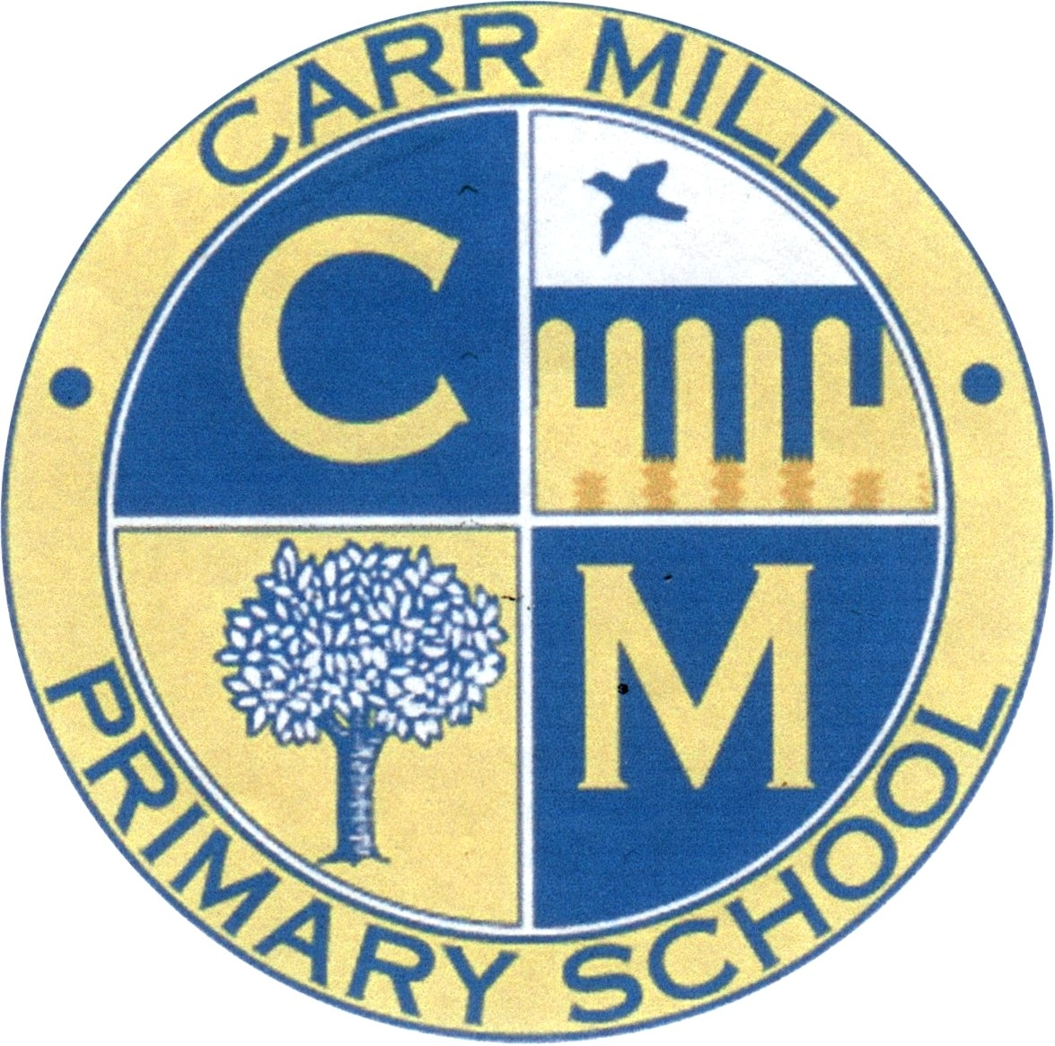

Charging and Remissions Policy
2022

Carr Mill Primary School
Charging and Remissions Policy

- Introduction

All education during school hours is free. We do not charge for any activity undertaken as part of the National Curriculum with the exception of individual or group music tuition.

- Aim

The aim of this policy is to set out what charges will be levied for activities, what remissions will be implemented and the circumstances under which voluntary contributions will be requested from parents.

- Responsibilities

The Governing Body are responsible for determining the content of the policy and the Head Teacher for implementation. Any determinations with respect to individual parents will be jointly considered by the Head Teacher and Governing Body.

- Prohibition of Charges

The Governing Body of the school recognise that the legislation prohibits charges for the following:

- Education provided during school hours (including the supply of any materials; books; instruments or other equipment);
- Education provided outside school hours if it is part of the National Curriculum, or part of the syllabus for a prescribed public examination that the pupil is being prepared for at the school, or part of religious education;
- Tuition for pupils learning to play musical instruments if the tuition is required as part of the National Curriculum, or part of a syllabus for a prescribed public examination that the pupil is being prepared for at the school, or part of religious education;
- Education provided on any trip that takes place during school hours;
- Education provided on any trip that takes place outside school hours if it is part of the National Curriculum, or part of a syllabus for a prescribed public examination that the pupil is being prepared for at school, or part of religious education;
- Supply teachers to cover for those teachers who are absent from school accompanying pupils on a residential trip;
- Transporting registered pupils to or from school premises where the governing body or local education authority has arranged for pupils to be educated;
- Transport provided in connection with an educational trip.

5. Publication of Information

A summary of this policy will be included in the school Prospectus which will specify what charges are/ are not to be made and for which activities voluntary contributions will be invited from parents.

- Charges

- Board and lodgings on residential visits (not to exceed the costs)
- Non-residential activities outside school hours (clubs). The proportionate costs for an individual child of activities wholly or mainly outside school hours (‘optional extras’) to meet the costs for:

  - Travel
  - Board and lodgings
  - Materials and equipment
  - Non-teaching staff costs
  - Entrance fees
  - Insurance costs

- Breakages and replacements, as a result of damages caused wilfully or negligently by pupils will be levied at the Head Teacher’s discretion.

- Cashless Payments
All payments can be made through our School Money App; however we are still accepting cash for some payments such as uniform and school dinners to allow a transition period for parents to get the app.

- Voluntary Contributions

Parents will be invited to make voluntary contributions for educational visits.

The terms of any request to parents will specify that the request for a voluntary contribution in no way represents a charge. In addition, the following will be made clear to parents:

- that the contribution is genuinely voluntary, and a parent is under no obligation to pay; and
- that registered pupils at the school will not be treated differently according to whether or not their parents have made any contribution in response to the request.
- if insufficient contributions are raised, the trip or activity may have to be cancelled

The responsibility for determining the level of voluntary contribution is delegated to the Head teacher.
Voluntary contributions may be used for:
- costs of admissions to the venue such as a museum or zoo;
- cost of travel for pupils to and from the venue;
- travel insurance; and
- costs of travel for accompanying adult.

- Clubs

Children attending the Breakfast Bistro during the morning session before school will be charged £2 for the first child and then £1 per additional sibling. This contribution is payable by 12 noon each Thursday a week in advance.

If an outside agency is brought into school, it is at head teacher discretion to determine if payable by parents/carers when booking a place or paid via school budget/grant income.

School will not charge outside agencies for the use of the school premises for clubs or any other chargeable event. This is to prevent an increase to parents and to keep the club charge as low as possible.

- Uniform

We expect children to wear our school uniform which can be ordered through the school office. Full details of school uniform and costs can be found on the school website. We also expect children to be properly equipped for PE lessons wearing the appropriate kit.

- Charities

From time to time, the school may decide to allow children to come to school in their own choice of clothes or raise money for a charity such as through a coffee morning for Macmillan/ Comic relief etc. We ask for a voluntary donation on these occasions of money or an item that may be sold to raise money. If a parent wishes their child to take part in non-uniform day but is unwilling to make a voluntary contribution, we do allow the child to participate fully.

- School Dinners

Parents/carers reserve the right to choose whether their child has school dinners, or a packed lunch brought from home. Parents/carers who wish their KS2 child to have a school dinner are required to provide the School Office with their payment on a weekly or termly basis in advance. There will be no charge for children entitled to benefit related free school meals. Non-payment of dinner money will be pursued. A debt of £20 will trigger an initial letter with a further letter to follow after 14 days, after which the debt is then transferred to the Council Finance Department to pursue.

- Milk

Infant children can have milk which is subsidised with a resulting cost of £6 per year. Children entitled to benefit related free school meals will also receive free milk. Parents will be requested to pay for milk annually or termly at the school office. We act sympathetically and supportively towards families who may not be able to afford to pay, however unless the family alert us to this the debt will be pursued.

- Snacks

Healthy bagels are available in school for children to access in the morning free of charge. School is part of the Government’s “Fruit for Schools” scheme and endeavour that all infant children receive a fair allocation of the fruit received into school through this scheme. This is also now offered to all of our KS2 children.

- Other
Over the course of the school year in association with the school PTA we may hold events for the children such as Father Christmas visits/ discos etc. The PTA budget pays for these and any contribution from the children is non profit and will just cover costs of food/ drink. The school PTA the Friends of Carr Mill raise money through events such as bingo, where children come into school in non-uniform. They are asked to make a voluntary contribution for this, this can be monetary or in the form of an item such as chocolate. Again, if there is a parent wishes their child to take part in non-uniform day but is unwilling to make a voluntary contribution, we do allow the child to participate fully. All money raised is sent to the school fund.

- Remissions

The Governing Body may wish to remit in full or part the cost of school activities which forms part of the syllabus or National Curriculum for particular groups of parents, for example, in the case of family hardship. When arranging a chargeable activity such parents will be invited in confidence for the remission of charges in full or in part. Authorisation for such remissions will be made by the head teacher in consultation with the Governors.

